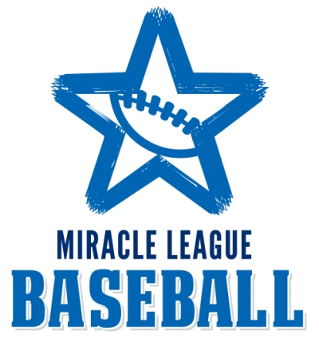

|  |  |  |  |  |  |  |  |  |  |  |  |  |  |  |  |  |  |  |  |  |  |  |  |  |  |  |  |  |  |  |  |  |  |  |  |  |  |  |  |  |  |  |  |  |  |
| --- | --- | --- | --- | --- | --- | --- | --- | --- | --- | --- | --- | --- | --- | --- | --- | --- | --- | --- | --- | --- | --- | --- | --- | --- | --- | --- | --- | --- | --- | --- | --- | --- | --- | --- | --- | --- | --- | --- | --- | --- | --- | --- | --- | --- | --- |
| |  |  |  | | --- | --- | --- | | Schedule |  | | | Day | Date/Time | Game Day Events | Notes | | Thursday | September 18 @  6pm | Opening Night | ALL TEAMS  Sponsored by South Atlantic Bank  ALL TEAMS  Sponsored by Springmaid Beach Resort  ALL TEAMS  ALL TEAMS  ALL TEAMS  ALL TEAMS  Sponsored by Sam’s Club  ALL TEAMS | | Saturday | September 27 @  10am | Game Day | | Saturday | October 4 @  10am | Game Day | | Saturday | October 11 @  10am | Game Day | | Friday | October 17 @  6pm | Game Day | | Friday | October 24 @  6pm | Halloween Night | | Saturday | November 1 @  10am | Game Day | | Saturday | November 8 @  10am | Game Day | ALL TEAMS | |  |  |  |  | |  |  |  |  | | Saturday | May 17 @ 10am | Pelican’s Day & Season Finale | ALL TEAMS | |